BINANCE CONVERT USING PYTHON

# CREATE TEST ORDER

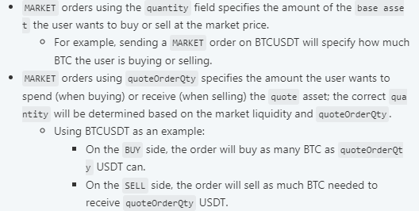

*Figure showing the Buy metrics for create test_order.*